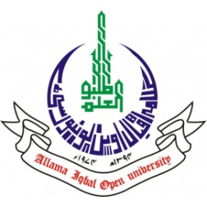
ALLAMA IQBAL OPEN UNIVERSITY, ISLAMABAD
(Office of Research, Innovation & Commercialization)
Subject: Advertisement for the Post of Research Assistant in the Department of Islamic Thought, History & Culture under AIOU Internal Funded Research Project
Applications are invited for the following Position under AIOU Internal funded Project titled “سماجی انصاف سے متعلق اسلام اور مسیحت کی تعلیمات: تقابل اور عصری معنویت” in the Department of Islamic Thought, History & Culture, Faculty of Arabic & Islamic Studies, Allama Iqbal Open University, Islamabad:
Name of Post | Number of Posts | Qualification / Experience | Duration | Remuneration
Research Assistant | 01 | - Having MA /BS Islamic Studies degree or equivalent  - Preference will be given to MPhil / PhD scholars. | 04 months | Rs. 15,000/- per month.
Note:
- Please email application along with updated CV with active contact numbers, scans of educational testimonials, CNIC and experience certificates (if any) on riaz.mahmood@aiou.edu.pk by May 26, 2025.
- Incomplete or late applications shall not be entertained, and only shortlisted candidates will be called for test/interview.
- AIOU reserves the right to accept or reject any/all applications without assigning any reason.
- No TA/DA shall be admissible for test/interview.
- The positions are based at Islamabad Campus.
- This is a project appointment which will be on a contract basis.

Manager Research Operation
ORIC, AIOU

