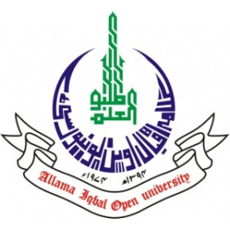
ALLAMA IQBAL OPEN UNIVERSITY, ISLAMABAD
(Office of Research, Innovation & Commercialization)

Subject: Advertisement for the Post of Research Assistant in the Department of Hadith & Hadith Sciences under AIOU Internal Funded Research Project
Applications are invited for the following Position under AIOU Internal funded Project titled "Eradication of Poverty in Pakistan, a Research Study in the Context of Umar bin Abdul Aziz's Initiatives and Reforms" in the Department of Hadith & Hadith Sciences, Faculty of Arabic & Islamic Studies, Allama Iqbal Open University, Islamabad:
Name of Post | Number of Posts | Qualification / Experience | Duration | Remuneration
Research Assistant | 01 | Having MPhil /MS Hadith & Seerah or equivalent. Preference will be given to experts in Computer & Arabic language. | 04 months | Rs. 15,000/- per month.
Note:
- Please email application along with updated CV with active contact numbers, scans of educational testimonials, CNIC and experience certificates (if any) on navid.iqbal@aiou.edu.pk by May 25, 2025.
- Incomplete or late applications shall not be entertained, and only shortlisted candidates will be called for test/interview.
- AIOU reserves the rights to accept or reject any/all applications without assigning any reason.
- No TA/DA shall be admissible for test/interview.
- The positions are based at Islamabad Campus.
- This is a project appointment which will be on a contract basis.

Manager Research Operation
ORIC, AIOU

