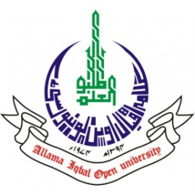
ALLAMA IQBAL OPEN UNIVERSITY, ISLAMABAD
(Office of Research, Innovation & Commercialization)

Subject: Advertisement for the Post of Research Assistant in the Department of Quran and Tafseer under AIOU Internal Funded Research Project
Applications are invited for the following Position under AIOU Internal funded Project titled "Constraints on Distribution and Use of Natural Resources in the Context of Climate Change: A Specific Study of Quranic Teachings" in the Department of Quran and Tafseer , Faculty of AIS, Allama Iqbal Open University, Islamabad:
Name of Post | Number of Posts | Qualification / Experience | Duration | Remuneration
Research Assistant | 01 | Having MPhil /MS Quran & Tafseer or equivalent. Preference will be given to PhD scholars. | 04 months | Rs. 15,000/- per month.
Note:
- Please email application along with updated CV with active contact numbers, scans of educational testimonials, CNIC and experience certificates (if any) on arshad.iqbal@aiou.edu.pk by May 30, 2025.
- Incomplete or late applications shall not be entertained and only shortlisted candidates will be called for test/interview.
- AIOU reserves the rights to accept or reject any/all applications without assigning any reason.
- No TA/DA shall be admissible for test/interview.
- The positions are based at Islamabad Campus.
- This is a project appointment which will be on contract basis.

Manager Research Operation
ORIC, AIOU

