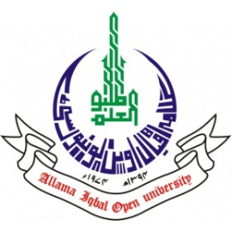
ALLAMA IQBAL OPEN UNIVERSITY, ISLAMABAD
(Office of Research, Innovation & Commercialization)

Subject: Advertisement for the Post of Research Assistant in the Department of Educational Planning Policy Studies and Leadership under AIOU Internal Funded Research Project
Applications are invited for the following Position under AIOU Internal funded Project titled “Pilot Testing of Peace Education Module” in the Department of EPPSL, Faculty of Education, Allama Iqbal Open University, Islamabad:
Name of Post | Number of Posts | Qualification / Experience | Duration | Remuneration
Research Assistant | 01 | Having MS/ MPhil in Educational Planning /Leadership and Management | 03 months | Rs. 15,000/- per month.
Note:
- Please email application along with updated CV with active contact numbers, scans of educational testimonials, CNIC, and experience certificates (if any) afshan.huma@aiou.edu.pk by May 30, 2025.
- Incomplete or late applications shall not be entertained, and only shortlistedcandidates will be called for test/interview.
- AIOU reserves the right to accept or reject any/all applications without assigning any reason.
- No TA/DA shall be admissible for test/interview.
- The positions are based on Islamabad Campus.
- This is a project appointment which will be on a contract basis.

Manager Research Operation
ORIC, AIOU

