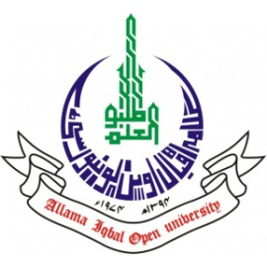
ALLAMA IQBAL OPEN UNIVERSITY, ISLAMABAD
(Office of Research, Innovation & Commercialization)

Subject: Advertisement for the Post of Research Assistant in the Department of Nutritional Sciences, and Environmental Design under AIOU Internal Funded Research Project
Applications are invited for the following Position under AIOU Internal funded Project titled "Enhancing Urban Resilience: The Role of Neighborhood Parks of Sector G-7, Islamabad in Climate Change Mitigation"in the Department of Nutritional Sciences, and Environmental Design, Faculty of Sciences, Allama Iqbal Open University, Islamabad:
Name of Post | Number of Posts | Qualification / Experience | Duration | Remuneration
Research Assistant | 01 | Having MS in Environmental Design, or Bachelor of Architecture, Urban / Town Planning, Civil Engineering, Environmental Sciences, or related fields. | 04 months | Rs. 15,000/- per month.
Note:
- Please email application along with updated CV with active contact numbers, scans of educational testimonials, CNIC, and experience certificates (if any) to nazia.iftakhar@aiou.edu.pk by April 07, 2025.
- Incomplete or late applications shall not be entertained and only shortlisted candidates will be called for test/interview.
- AIOU reserves the rights to accept or reject any/all applications without assigning any reason.
- No TA/DA shall be admissible for test/interview.
- The positions are based at Islamabad Campus.
- This is a project appointment which will be on contract basis.

Manager Research Operation
ORIC, AIOU

