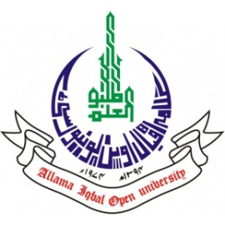
ALLAMA IQBAL OPEN UNIVERSITY, ISLAMABAD
(Office of Research, Innovation & Commercialization)

Subject: Advertisement for the Post of Research Assistant in the Department of Nutritional Sciences and Environmental Design (NS&ED) under AIOU Internal Funded Research Project
Applications are invited for the following Position under AIOU Internal funded Project titled "Solid Waste Management at AIOU Residential Colony: Situation Analysis and Improvement Measures to Optimize Resource Recovery and Reducing Carbon Footprint" in the Department of Nutritional Sciences, and Environmental Design, Faculty of Sciences, Allama Iqbal Open University, Islamabad:
Name of Post | Number of Posts | Qualification / Experience | Duration | Remuneration
Research Assistant | 01 | Having MS in Environmental Design, or Bachelor of Civil Engineering, Environmental Science, or related fields. | 04 months | Rs. 15,000/- per month.
Note:
- Please email application along with updated CV with active contact numbers, scans of educational testimonials, CNIC, and experience certificates (if any) torabeea.zafar@aiou.edu.pk by April 07, 2025.
- Incomplete or late applications shall not be entertained and only shortlisted candidates will be called for test/interview.
- AIOU reserves the rights to accept or reject any/all applications without assigning any reason.
- No TA/DA shall be admissible for test/interview.
- The positions are based at Islamabad Campus.
- This is a project appointment which will be on contract basis.

Manager Research Operation
ORIC, AIOU

