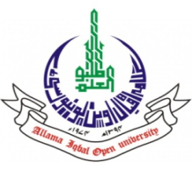
ALLAMA IQBAL OPEN UNIVERSITY, ISLAMABAD
(Office of Research, Innovation & Commercialization)

Subject: Advertisement for the Post of Research Assistant in the Department of Agricultural Sciences.
Applications are invited for the following Position under AIOU Internal funded Project titled “Capacity Building of the Small Farmers on Organic Crop Production for Food Security and Natural Resource Management” in the Department of Agricultural Sciences, Faculty of Sciences, Allama Iqbal Open University, Islamabad:
Name of Post | Number of Posts | Qualification / Experience | Duration | Remuneration
Research Assistant | 01 | BS/BSc Hons. Agriculture | 04 months | Rs. 15,000/- per month.

Note:
- Please email application along with updated CV with active contact numbers, scans of educational testimonials, CNIC and experience certificates (if any) on sabir.hussain@aiou.edu.pk by April 05, 2024.
- Incomplete or late applications shall not be entertained and only shortlisted candidate will be called for test/interview.
- AIOU reserves the rights to accept or reject any/all applications without assigning any reason.
- No TA/DA shall be admissible for test/interview.
- The positions are based at Islamabad Campus.
- This is a project appointment which will be on contract basis.

Manager Research Operation
ORIC, AIOU

