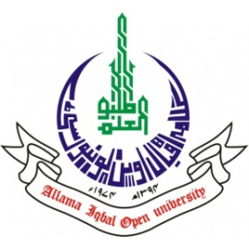
ALLAMA IQBAL OPEN UNIVERSITY, ISLAMABAD
Office of Research, Innovation & Commercialization)

Subject: Advertisement for the Post of Research Assistant in the Department of Biology under AIOU Internal Funded Research Project
Applications are invited for the following Position under AIOU Internal funded Project titled “Comprehensive profiling of bacterial community residing the gut of Gestational diabetes Mellitus patient based on 16SrRNA metagenomics” in the Department of Biology, Faculty of Sciences, Allama Iqbal Open University, Islamabad:
Name of Post | Number of Posts | Qualification / Experience | Duration | Remuneration
Research Assistant | 01 | - Having BS Microbiology  - Preference will be given to student enrolled in MPhil Microbiology | 01 months | Rs. 10,000/- per month.
Note:
- Please email application along with updated CV with active contact numbers, scans of educational testimonials, CNIC and experience certificates (if any) on email rizwana.kousar@aiou.edu.pk by January 16 , 2024.
- Incomplete or late applications shall not be entertained, and only shortlisted candidates will be called for test/interview.
- AIOU reserves the right to accept or reject any/all applications without assigning any reason.
- No TA/DA shall be admissible for test/interview.
- The positions are based at Islamabad Campus.
- This is a project appointment which will be on a contract basis.

Manager Research Operation
ORIC, AIOU

