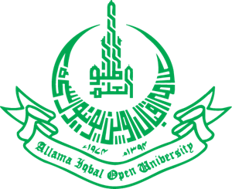
Allama Iqbal Open University, Islamabad
(Office of Research, Innovation & Commercialization)

Subject: Advertisement for the Post of Research Assistant in the Department of Distance, Non-Formal and Continuing Education under AIOU Internal Funded Research Project.

Applications are invited for the following Position under AIOU Internal funded Project titled “Effect of Cooperative Learning Intervention on Faculty’s Understanding, Self-Efficacy and Implementation of the Pedagogy” in the Department of Distance, Non-Formal Continuing Education, Faculty of Education, Allama Iqbal Open University, Islamabad:

Name of Post | Number of Posts | Qualification/ Experience | Duration | Remuneration
Research Assistant | 01 | The candidate must have completed M.A/MSc in any subject from Social Sciences from an HEC approved Institution.  Preference will be given to the candidates:  - having experience in Research Projects as Research Assistant  - proficient in the use of Microsoft Office (Word, Excel, Powerpoint) and understands basics of SPSS | 04 months | Rs. 15,000/- per month

Note:
- Please email the application along with an updated CV with active contact numbers, scans of educational testimonials, CNIC, and experience certificates (if any) to zaheer.ahmad@aiou.edu.pkby December15, 2023.
- Incomplete or late applications shall not be entertained and only shortlisted candidates will be called for test/interview.
- AIOU reserves the right to accept or reject any/all applications without assigning any reason.
- No TA/DA shall be admissible for test/interview.
- The positions are based at Islamabad Campus.
- This project appointment will be purely on a contract basis.

Manager Research Operation
ORIC, AIOU

