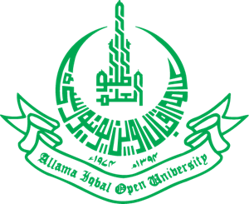
Allama Iqbal Open University, Islamabad
(Office of Research, Innovation & Commercialization)

Subject: Advertisement for the Post of Research Assistant in the Interfaith Studies under AIOU Internal Funded Research Project.

Applications are invited for the following Position under AIOU Internal funded Project titled “A critical Edition of Hafiz Jamal Allah's Persian Hagiographies” in the Department of Interfaith Studies, Faculty of Arabic & Islamic Studies, Allama Iqbal Open University, Islamabad:

Name of Post | Number of Posts | Qualification/ Experience | Duration | Remuneration
Research Assistant | 01 | Postgraduate degree preferably in Persian. Must have expertise in Arabic & Persian Languages. | 04 months | Rs. 15,000/- per month

Note:
- Please email the application along with an updated CV with active contact numbers, scans of educational testimonials, CNIC, and experience certificates (if any) to shams.rehman@aiou.edu.pk by December15, 2023.
- Incomplete or late applications shall not be entertained and only shortlisted candidates will be called for test/interview.
- AIOU reserves the right to accept or reject any/all applications without assigning any reason.
- No TA/DA shall be admissible for test/interview.
- The positions are based at Islamabad Campus.
- This project appointment will be purely on a contract basis.

Manager Research Operation
ORIC, AIOU

