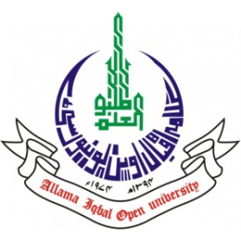
ALLAMA IQBAL OPEN UNIVERSITY, ISLAMABAD
(Office of Research, Innovation & Commercialization)

Subject: Advertisement for the Post of Research Associate in the Department of Biology under Pakistan Science Foundation Project PSF/NSLP/C-AIOU (1032)
Applications are invited for the following Position under PSF funded Project titled “Development of Nanotherapeutics based on Phyto Fabrication of Metal Oxide Nano Particles” in the Department of Biology, Faculty of Sciences, Allama Iqbal Open University, Islamabad:
Name of Post | Number of Posts | Qualification / Experience | Duration | Remuneration
Research Associate | 01 | MS / MPhil degree in the field of Biology with at least two first divisions (one in MS / MPhil and no third division in the academic career)  Experience of post MS / MPhil research in the relevant field will be given preference. | 6 months (extendable till the project completion) | Rs. 25,000/- per month.
Note:
- Interested candidates can submit (by hand/post/email) their application along with attested copies of academic documents, experience certificates and CV till 30th November 2023 to the following address:
Dr. Sobia Kanwal, Principal Investigator
Department of Biology
Allama Iqbal Open University, Islamabad
OR
sobia.kanwal@aiou.edu.pk
- Incomplete or late applications shall not be entertained, and only shortlisted candidate will be called for test/interview.
- AIOU reserves the rights to accept or reject any/all applications without assigning any reason.
- No TA/DA shall be admissible for test/interview.
- The positions are based at Islamabad Campus.
- This is a project appointment which will be on contract basis.

Manager Research Operation
ORIC, AIOU

