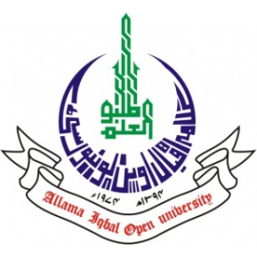
ALLAMA IQBAL OPEN UNIVERSITY, ISLAMABAD
(Office of Research, Innovation & Commercialization)

Subject: Advertisement for the Post of Research Assistant in the Department of Shariah under AIOU Internal Funded Research Project
Applications are invited for the following Position under AIOU Internal funded Project titled “Right of Private Defense in five Maqasid Al Shariah: A Comparative Study between Common Law and Islamic Law” in the Department of Shariah, Faculty of Arabic & Islamic Studies, Allama Iqbal Open University, Islamabad:
Name of Post | Number of Posts | Qualification / Experience | Duration | Remuneration
Research Assistant | 01 | MA Islamic Studies / Arabic or equivalent | 04 months | Rs. 15,000/- per month.
Note:
- Please email application along with updated CV with active contact numbers, scans of educational testimonials, CNIC and experience certificates (if any) on hidayat.khan@aiou.edu.pk by October 25, 2023.
- Incomplete or late applications shall not be entertained and only shortlisted candidates will be called for test/interview.
- AIOU reserves the rights to accept or reject any/all applications without assigning any reason.
- No TA/DA shall be admissible for test/interview.
- The positions are based at Islamabad Campus.
- This is a project appointment which will be on contract basis.

Manager Research Operation
ORIC, AIOU

