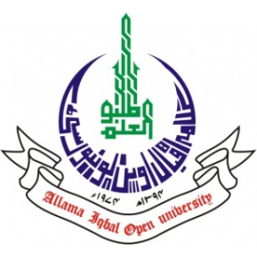
ALLAMA IQBAL OPEN UNIVERSITY, ISLAMABAD
(Office of Research, Innovation & Commercialization)

Subject: Advertisement for the Post of Research Assistant in the Department of Science Education under AIOU Internal Funded Research Project
Applications are invited for the following Position under AIOU Internal funded Project titled “Developing Graded Vocabulary-based Learning Material for Language Learners: A Corpus-based Study in Pakistani Context” in the Department of Science Education, Faculty of Education, Allama Iqbal Open University, Islamabad:
Name of Post | Number of Posts | Qualification / Experience | Duration | Remuneration
Research Assistant | 01 | Masters/ BS in Education preferably MPhil/MS Education | 04 months | Rs. 15,000/- per month.
Note:
- Please email application along with updated CV with active contact numbers, scans of educational testimonials, CNIC and experience certificates (if any) on nasir.mahmood@aiou.edu.pk by October 06, 2023.
- Incomplete or late applications shall not be entertained and only shortlisted candidate will be called for test/interview.
- AIOU reserves the rights to accept or reject any/all applications without assigning any reason.
- No TA/DA shall be admissible for test/interview.
- The positions are based at Islamabad Campus.
- This is a project appointment which will be on contract basis.

Manager Research Operation
ORIC, AIOU

